PRICE LIST 2024
*Trio Set mit Pixel PRO 2.0 C


Colour | Code | Parameters | EAN | Price | RRP | Ordered number
Grey  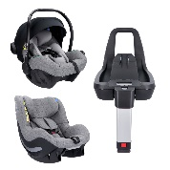 | 04616 TRIO 2.0 C PIXEL 01 GREY | i-Size R.129,  40-105 cm  0-17,5 kg  AGR | 5907603464190 | 530 € | 749 €
Beige  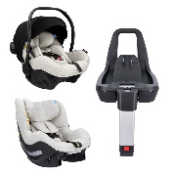 | 04617 TRIO 2.0 C PIXEL 02 BEIGE | i-Size R.129,  40-105 cm  0-17,5 kg  AGR | 5907603464299 | 530 € | 749 €
Black  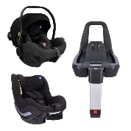 | 04618 TRIO 2.0 C PIXEL 03 BLACK | i-Size R.129,  40-105 cm  0-17,5 kg  AGR | 5907603464404 | 530 € | 749 €
Navy  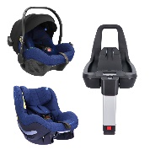 | 04619 TRIO 2.0 C PIXEL 04 NAVY | i-Size R.129,  40-105 cm  0-17,5 kg  AGR | 5907603464411 | 530 € | 749 €
Pink  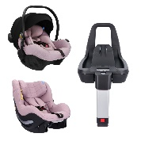 | 04620 TRIO 2.0 C PIXEL 05 PINK | i-Size R.129,  40-105 cm  0-17,5 kg  AGR | 5907603464428 | 530 € | 749 €
Mint  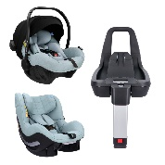 | 04621 TRIO 2.0 C PIXEL 06 MINT | i-Size R.129,  40-105 cm  0-17,5 kg  AGR | 5907603464435 | 530 € | 749 €

*Trio set mit Cosmo

Colour | Code | Parameters | EAN | Price | RRP | Ordered number
Grey  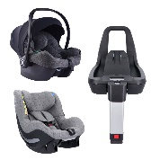 | 04623 TRIO 2.0 C COSMO 01 GREY | i-Size R.129,  40-105 cm  0-17,5 kg | 5907603464442 | 472 € | 649 €
Mint  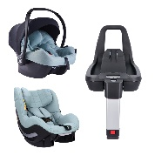 | 04622 TRIO 2.0 C COSMO 02 MINT | i-Size R.129,  40-105 cm  0-17,5 kg | 5907603464459 | 472 € | 649 €
Black  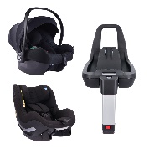 | 04624 TRIO 2.0 C COSMO 03 BLACK | i-Size R.129,  40-105 cm  0-17,5 kg | 5907603464466 | 472 € | 649 €

*Sets bestehen aus Babyschale, Aerofix 2.0 C und IQ-Base 2.0 C

